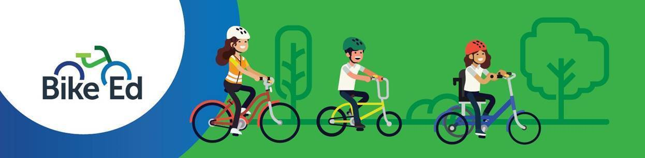

Case Study – Bike Ed (P - 12 School)

Tarneit P–9 College
Tarneit P–9 College is a large government school in Melbourne’s west, with more than 2,100 students from Prep to Year 9. The school is committed to inclusive, high-quality teaching and learning, with a strong focus on student wellbeing, engagement and future-ready skills.

Bringing Bike Ed to Life
Tarneit P–9 College is introducing Bike Ed to help students build the skills and confidence needed to ride safely and independently. Led by an experienced PE teacher, the program responds to the growing number of students who already ride to school and need practical road safety skills.
The long-term vision is for Bike Ed to be delivered from Levels 3–9 through PE, while Foundation to Year 2 students participate in scooter-based activities that develop balance, coordination and safety awareness.

Building a Sustainable Program
A key focus is training staff and parent volunteers as Bike Ed Instructors, creating a skilled support network to deliver safe, high-quality lessons. The school is also establishing the resources needed for whole-school implementation, including bikes, curriculum materials and staff professional learning.
With strong student interest and an active school community, Bike Ed is set to become a valuable part of Tarneit P–9 College’s road safety, wellbeing and active travel culture.

