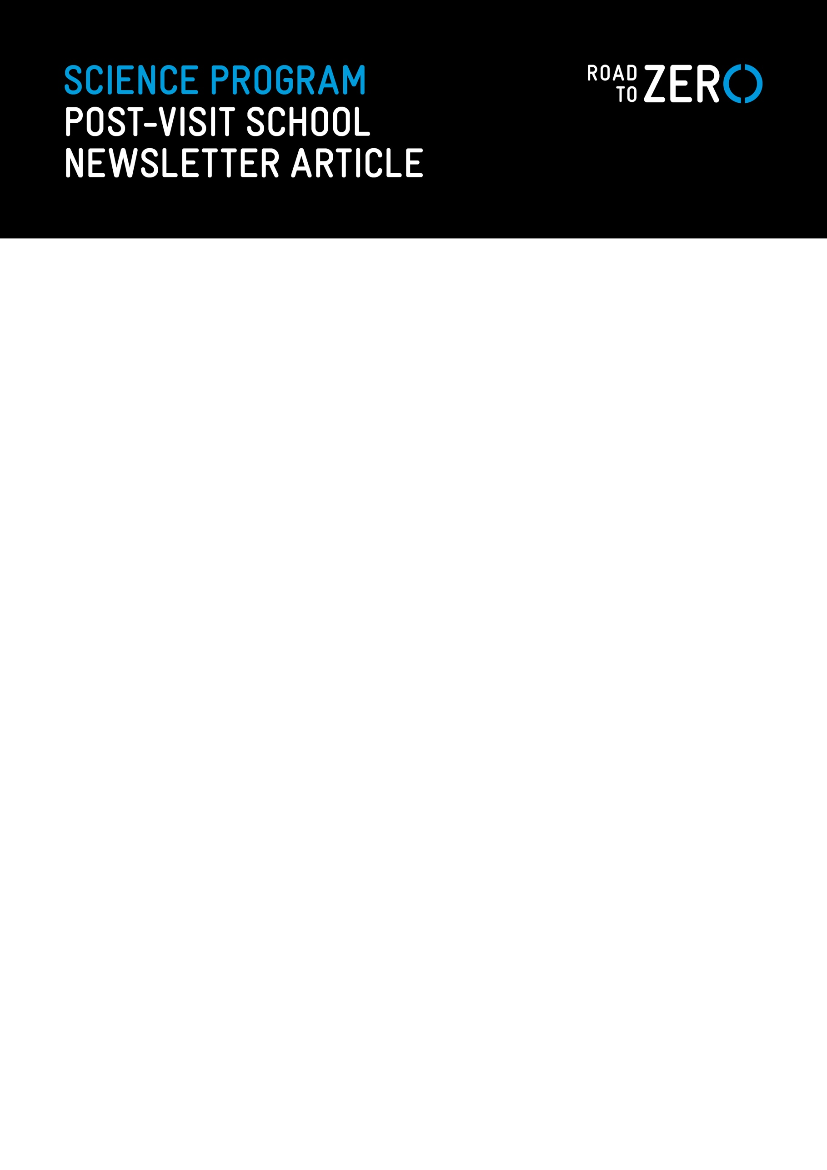

OUR YEAR [INSERT LEVEL & SUBJECT E.G 10 SCIENCE] STUDENTS EMBARK ON ROAD TO ZERO

Our [insert Year level/s and subject] students recently visited the world-leading Road to Zero Education Complex at Melbourne Museum.

Developed by the TAC in partnership with Melbourne Museum, Road to Zero examines road safety through a scientific lens and encourages students to apply what they learn to a real-world challenge – making every journey a safe one.

In the immersive exhibition space, students interacted with virtual reality technology and large-scale projections exploring the science and physics principles related to road safety, highlighting our physical vulnerability as well as the effect of safe speeds, road design, vehicle choices and road user behaviours.

In the Learning Studio, students worked collaboratively on the Road to Zero Physics Challenge, an experiment exploring the relationship between speed and friction on car stopping distances and building knowledge of Newton’s Laws of Motion.

A strong message from the excursion and learning activities undertaken back in class is that road safety is a shared responsibility – one that extends to all students and members of our school community.

For more information about Road to Zero – offered free to all Victorian secondary schools – visit roadtozero.vic.gov.au. Road to Zero is also open to general public visitors.

