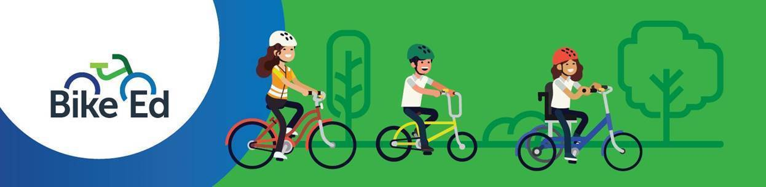Case Study – Bike Ed (Primary School)

Mount View Primary School
Mount View Primary School is a large primary school in Glen Waverley, with more than 900 students and a strong commitment to inclusive learning, wellbeing and student success. The school serves a diverse community and provides a wide range of learning opportunities both inside and outside the classroom.

Building Confidence Through Bike Ed
Bike Ed is a key part of the Year 4 program at Mount View Primary School, helping students develop bike-riding skills, road safety knowledge and the confidence to ride safely in their community.
The program is designed to support all learners, regardless of their previous experience. For students who are new to bike riding, additional one-on-one coaching ensures everyone has the opportunity to participate and succeed.

Learning by Riding
Each year, around 140 Year 4 students take part in Bike Ed. The program begins with skill development in PE, where students learn bike handling, gear use, road rules, group riding and safe riding behaviours.
As their confidence grows, students progress to supervised rides beyond the school grounds, applying their skills in real-world settings. Students ride in small groups supported by trained staff and parent volunteers, creating a safe and supportive learning environment.
The program culminates in a celebration ride, with distances tailored to students’ ability levels. For some, this includes a 45 km return ride to Melbourne’s CBD, showcasing just how far their skills and confidence have developed.

Lasting Impact
The Bike Ed program has had a significant impact on student confidence, independence and road safety awareness. Teachers report that students demonstrate safer behaviours as both bike riders and pedestrians, with many choosing to ride to school more often after completing the program.
A key factor in the program’s success is the investment in staff capability. All participating teachers are Bike Ed accredited, and Year 6 student leaders play an active role in supporting and encouraging younger students.

Top Tips for Other Schools
- Differentiate learning and support so every student can participate successfully.
- Invest in staff training and student leadership opportunities.
- Build strong partnerships with families and community organisations.
- Address bike and equipment access early in the planning process.
- Celebrate student achievements to build engagement and confidence.

Student Voice
Alex – Student
“Bike Ed was a really fun experience for me. When I first started, I couldn’t ride a bike at all, and now I can ride confidently and I love to ride with my family and friends. I’m so proud of myself. I learned that if you keep trying, you can achieve anything. My Dad and my PE teacher helped me so much, and I’m very grateful to them. I will definitely keep riding because I LOVE it!”

