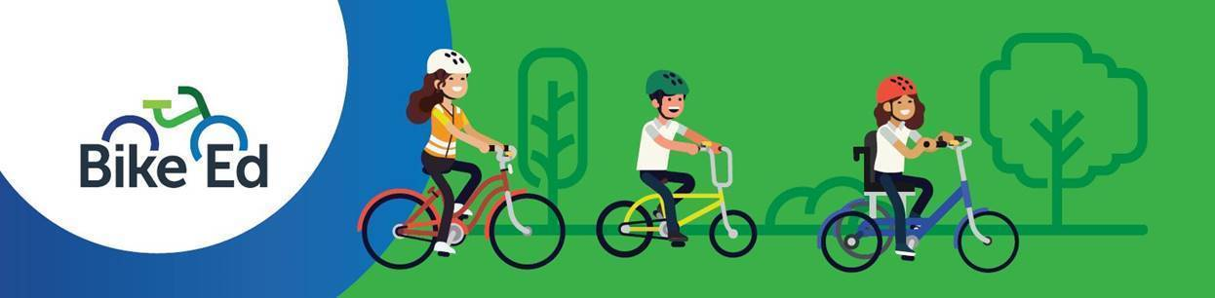

Case Study – Bike Ed (Secondary School)

Lilydale Heights College
Lilydale Heights College is a government secondary school in Melbourne’s outer east, serving around 835 students from Years 7–12. The College promotes student wellbeing, engagement and lifelong learning through a wide range of academic, sporting and co-curricular opportunities.

Growing Bike Ed Across the School
Lilydale Heights College has steadily expanded Bike Ed by removing barriers to participation and embedding bike riding into the curriculum. What began in Years 10–12 has grown to include Year 8 Physical Education and a Year 8 sport option, helping students build bike-riding skills and confidence from an earlier age.
Recognising that many students could not bring their own bikes to school, the College used grant funding to expand its bike fleet, making the program more accessible and allowing more students to participate.

Building Skills, Capacity and Culture
A major strength of the program is the College’s investment in staff training. More than 20 teachers have become accredited Bike Ed Instructors, creating a strong foundation for consistent, high-quality delivery and long-term sustainability.
Student involvement extends beyond the classroom. Through the Hands On Learning program, students have helped build secure bike racks and helmet storage, while a popular after-school Bike Club and bike camp provide additional opportunities to develop bike-riding skills, confidence and a love of being active outdoors.
Looking ahead, the College plans to further increase accessibility through additional bikes, explore bike maintenance projects, and continue working with local partners to support program growth.

Top Tips for Other Schools
- Secure strong leadership support to help drive planning, implementation and sustainability.
- Train multiple staff as Bike Ed Instructors to build capacity and flexibility.
- Partner with local bike shops, clubs and community groups to access expertise, resources and ongoing support.

