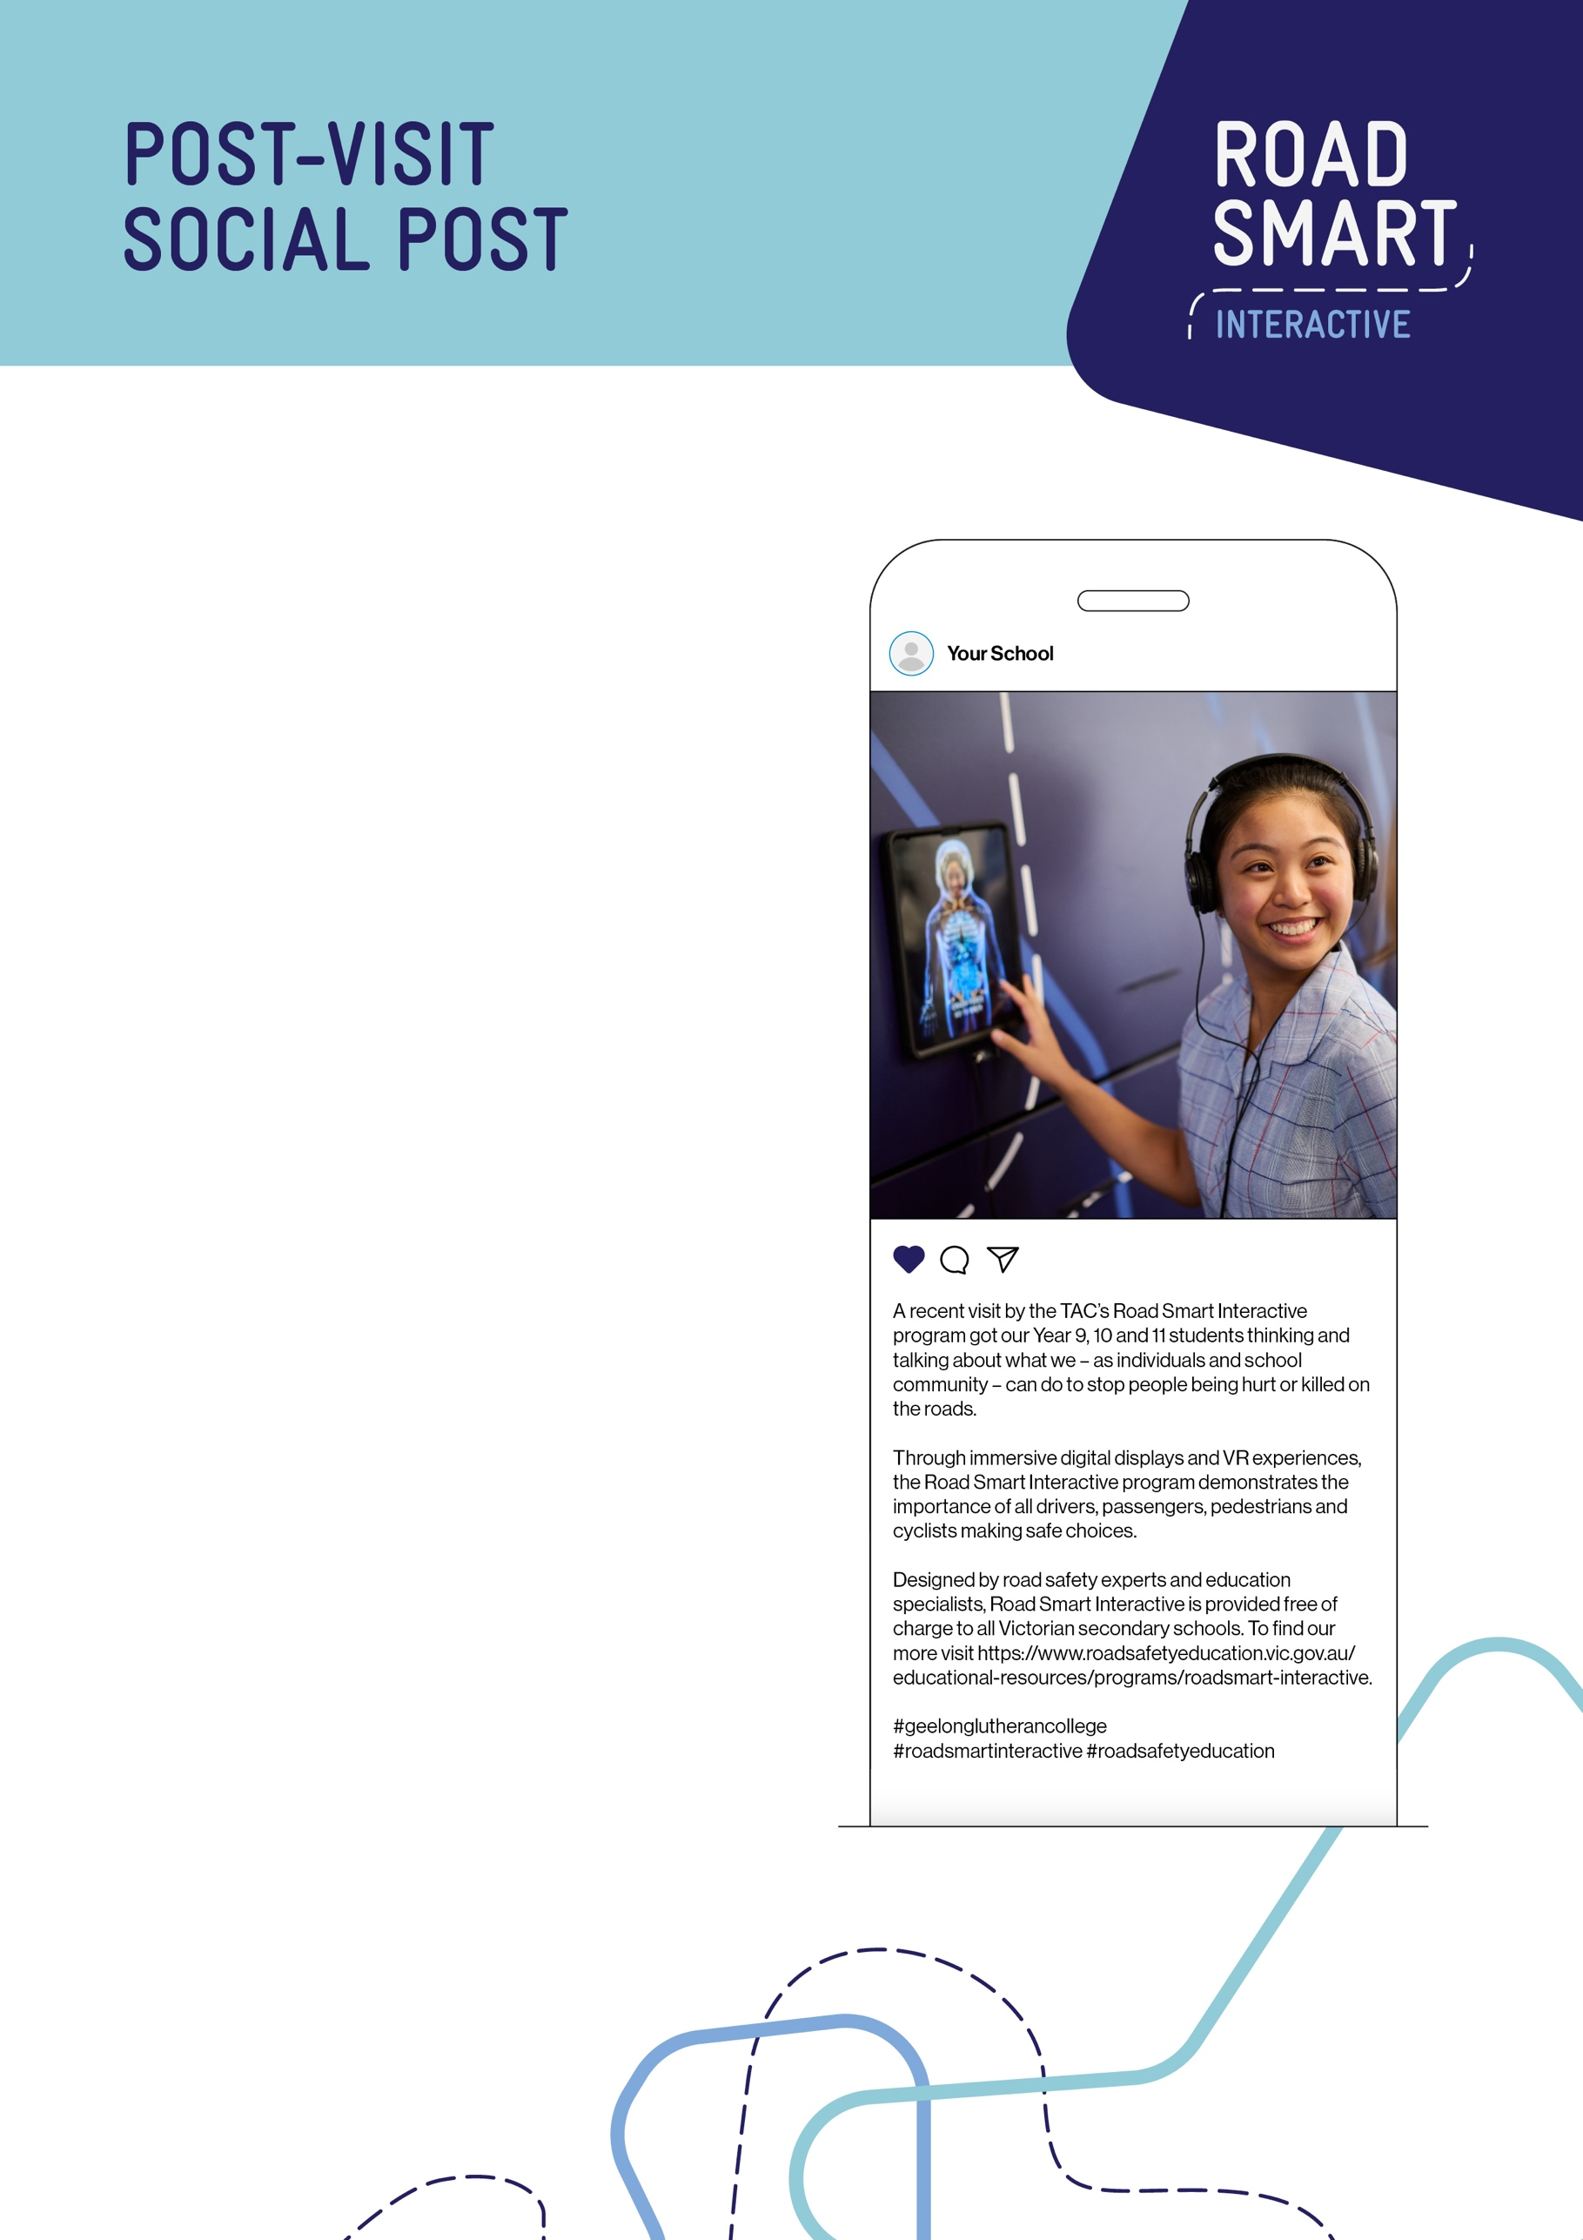

Caption text:
A recent visit by the TAC’s Road Smart Interactive program got our Year 9, 10 and 11 students thinking and talking about what we – as individuals and school community – can do to stop people being hurt or killed on the roads.

Through immersive digital displays and VR experiences, the Road Smart Interactive program demonstrates the importance of all drivers, passengers, pedestrians and cyclists making safe choices.

Designed by road safety experts and education specialists, Road Smart Interactive is provided free of charge to all Victorian secondary schools. To find our more visit https://www.roadsafetyeducation.vic.gov.au/ educational-resources/programs/roadsmart-interactive.

[Insert school #s]
#roadsmartinteractive #roadsafetyeducation

