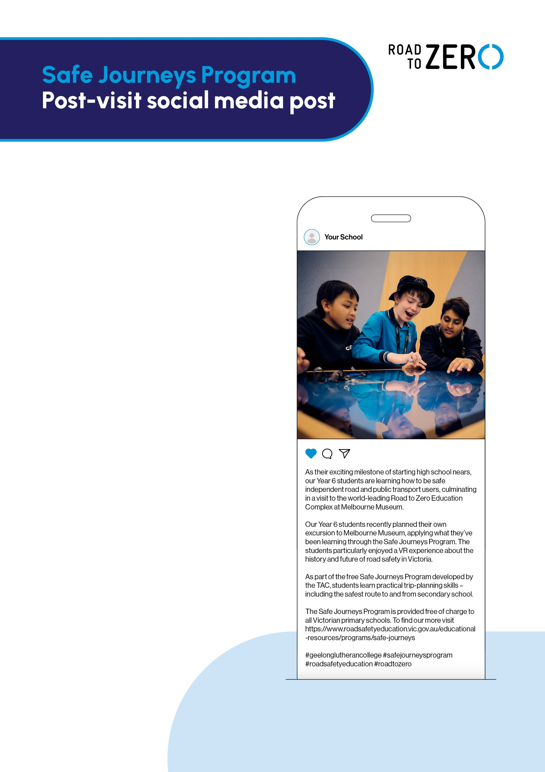

Caption text:
As their exciting milestone of starting high school nears, our Year 6 students are learning how to be safe independent road and public transport users, culminating in a visit to the world-leading Road to Zero Education Complex at Melbourne Museum.

Our Year 6 students recently planned their own excursion to Melbourne Museum, applying what they’ve been learning through the Safe Journeys Program. The students particularly enjoyed a VR experience about the history and future of road safety in Victoria.

As part of the free Safe Journeys Program developed by the TAC, students learn practical trip-planning skills – including the safest route to and from secondary school.

The Safe Journeys Program is provided free of charge to all Victorian primary schools.
To find our more visit https://www.roadsafetyeducation.vic.gov.au/educational-resources/programs/safe-journeys

[Insert school #s]
#safejourneysprogram #roadsafetyeducation #roadtozero

