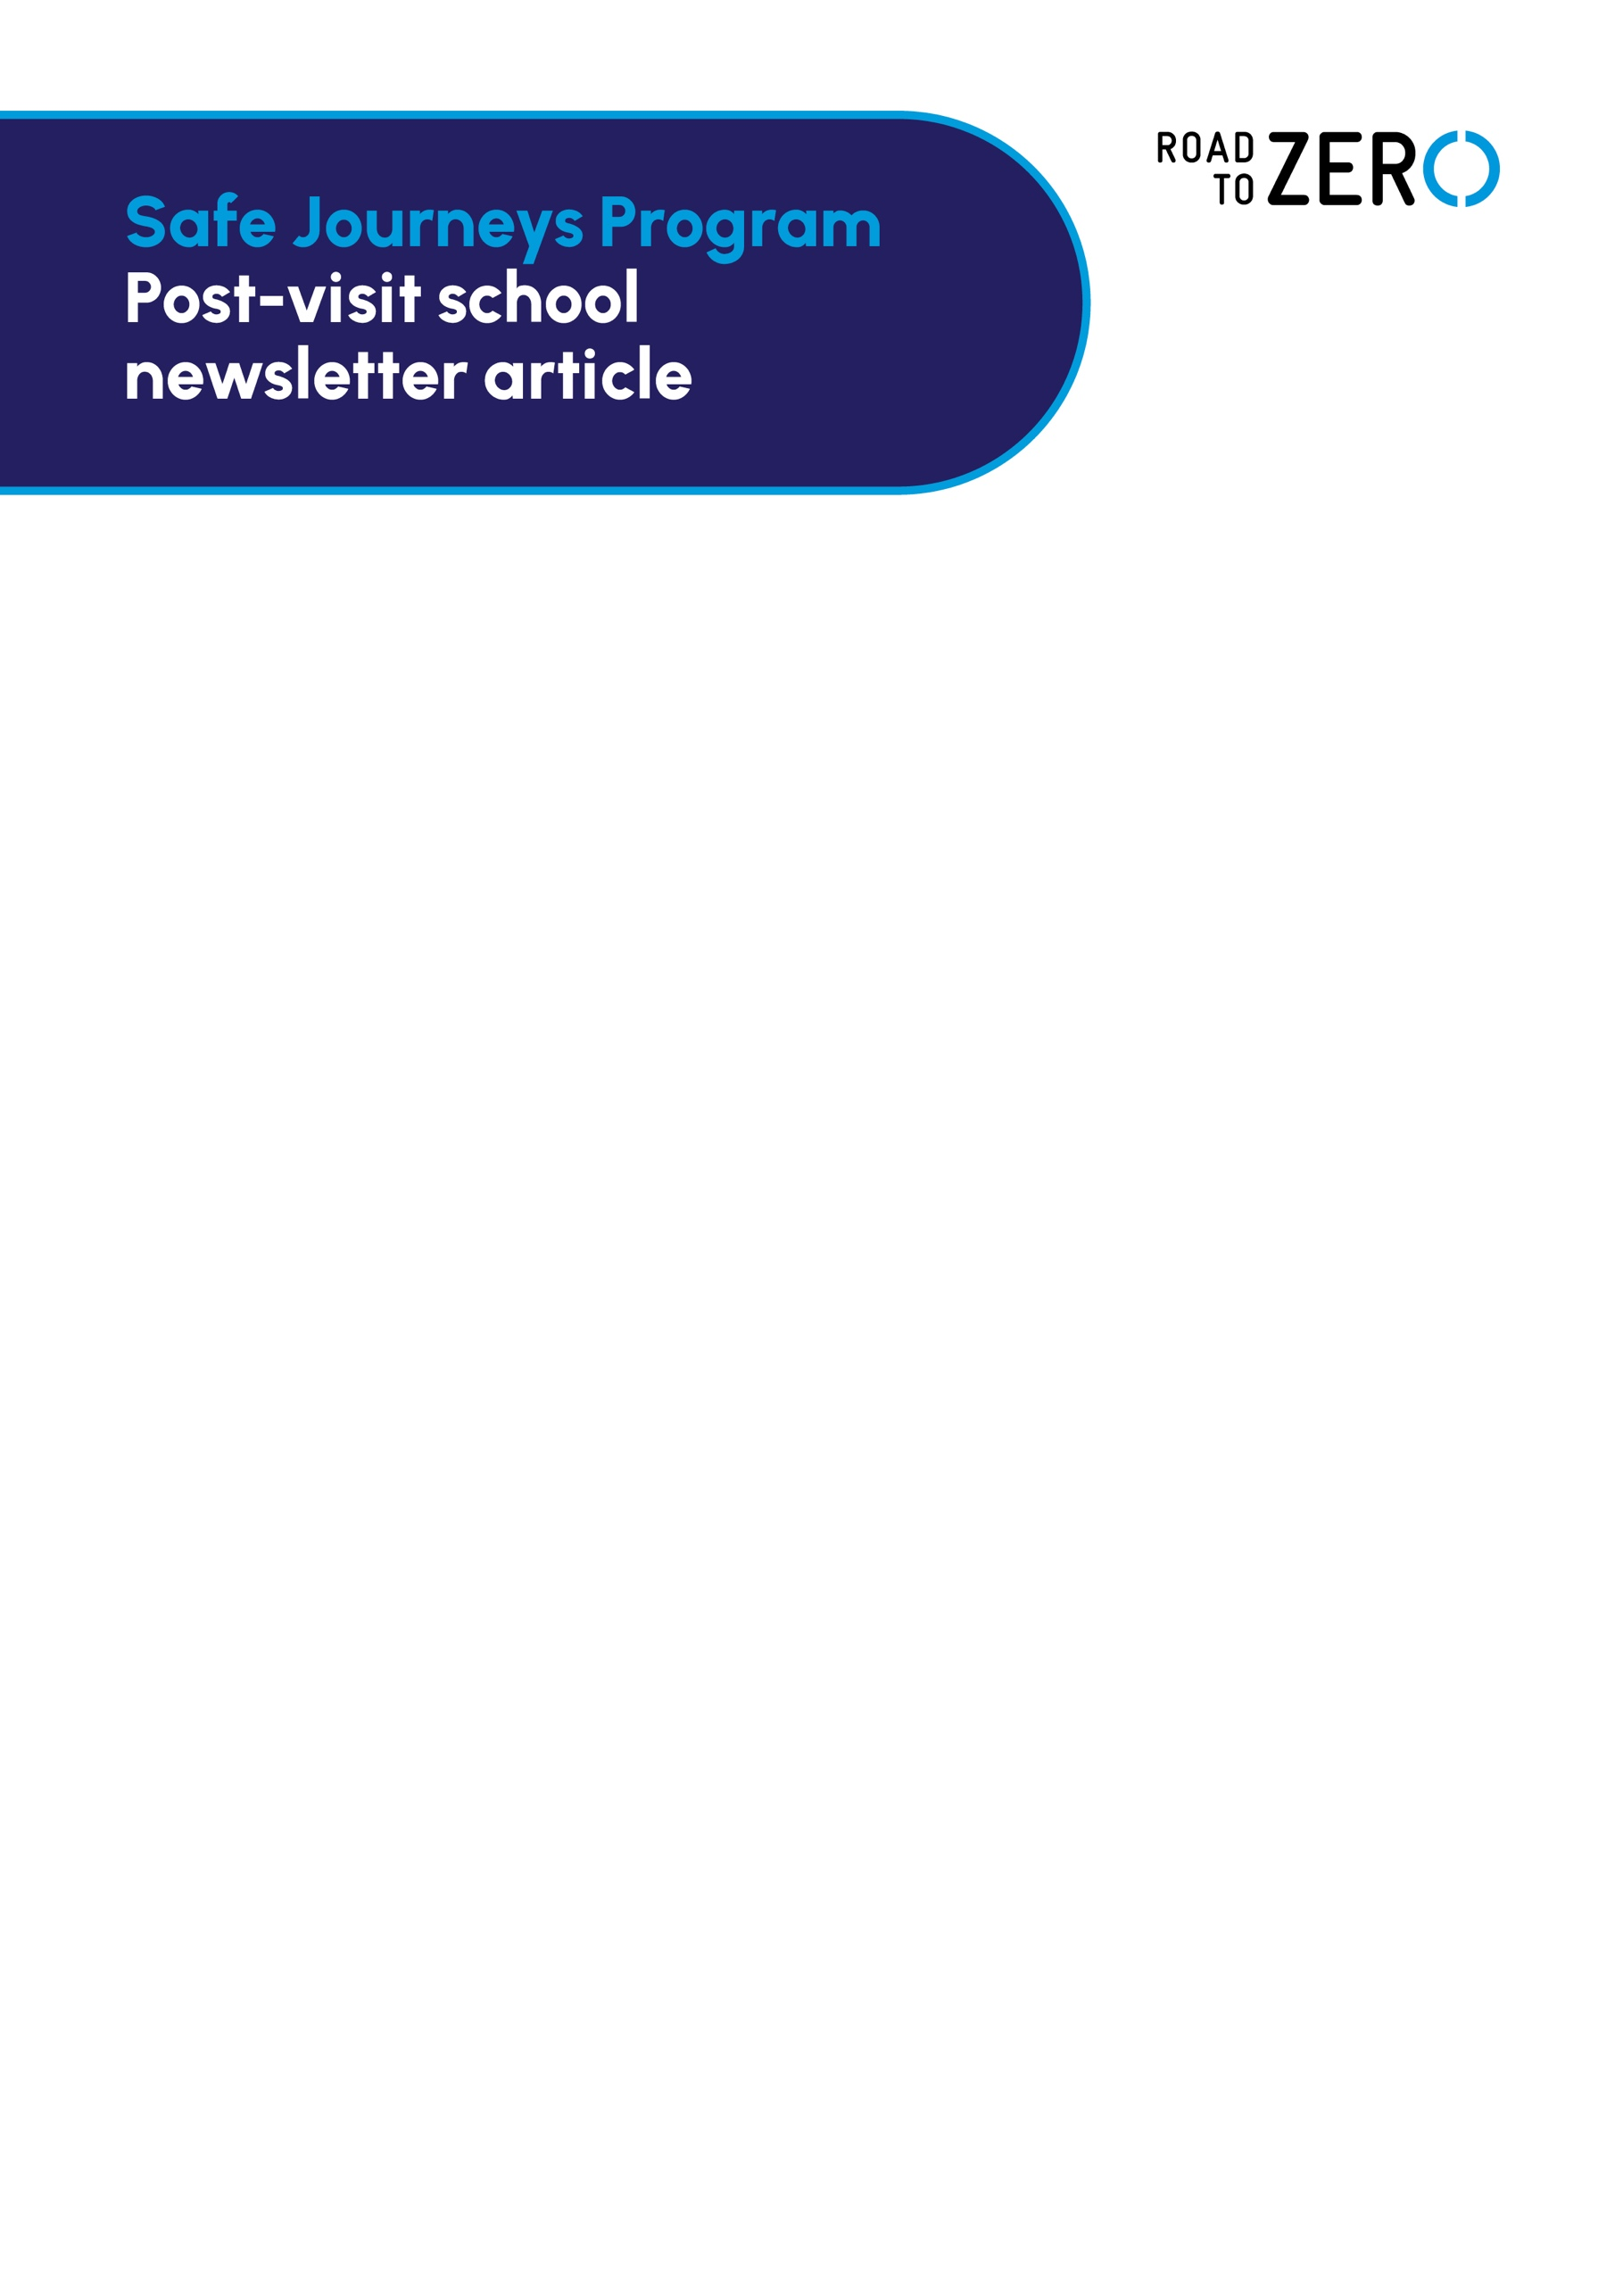

OUR YEAR 6 STUDENTS LEADING THE WAY IN ROAD SAFETY

Our Year 6 students recently participated in the TAC’s Safe Journeys Program, learning how to
be safe independent travellers as they near the exciting milestone of starting secondary school.

The 10-lesson program covered practical trip-planning skills – including the best route to and
from secondary school – as well as safe road and public transport practices.

A highlight of the program was a chance for the students to apply their newly acquired knowledge to planning and undertaking a safe journey (excursion) to the TAC’s world-leading Road to Zero Education Complex at Melbourne Museum.

Students had to work out the best and safest way to travel to the city by using online searches
as well as considering what tickets they needed, which stations/stops to get on and off as well as how to be respectful to fellow commuters.

In the immersive exhibition space at Road to Zero, students interacted with the latest digital
technology and large-scale projections to explore road safety topics and the importance of
making each journey a safe one.

Popular Road to Zero exhibits were a simulated elevator drop demonstrating crash forces and a
VR experience depicting the history and future of road safety in Victoria.

In the Learning Studio, students worked in small groups to create their own road safety ads on
the theme of cyclist or pedestrian safety using touch table technology.

For more information about Road to Zero visit roadtozero.vic.gov.au. Road to Zero is also open to general public visitors free of charge.

