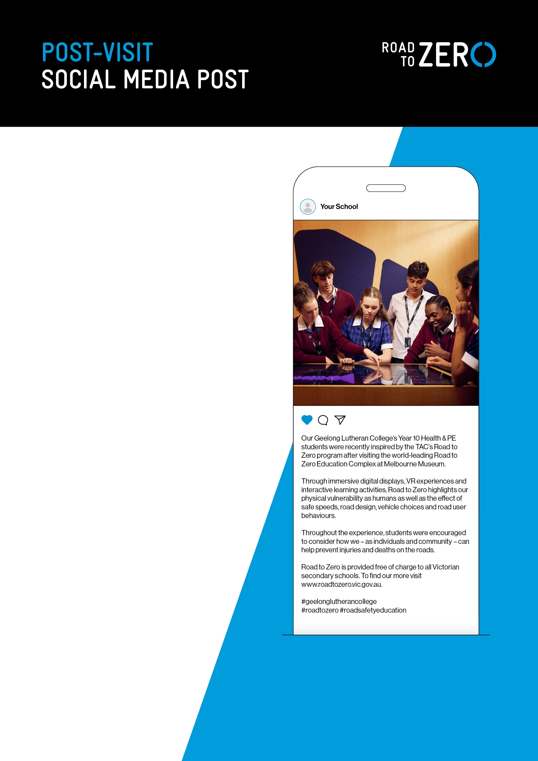

Caption text:
Our [insert Year level/s and subject] students were recently inspired by the TAC’s Road
to Zero program after visiting the world-leading Road to Zero Education Complex at Melbourne Museum.

Through immersive digital displays, VR experiences and interactive learning activities, Road to Zero highlights our physical vulnerability as humans as well as the effect of safe speeds, road design, vehicle choices and road user behaviours.

Throughout the experience, students were encouraged to consider how we – as individuals and community – can help prevent injuries and deaths on the roads.

Road to Zero is provided free of charge to all Victorian secondary schools. To find our more visit www.roadtozero.vic.gov.au.

[Insert school #s]
#roadtozero #roadsafetyeducation

